Flags of the World
Flag of Japan. Find the white area
Flag of Niger. Find the area of each colour
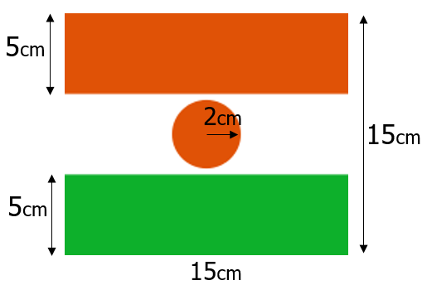
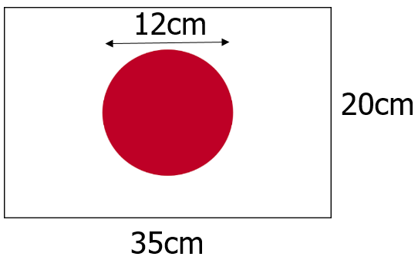

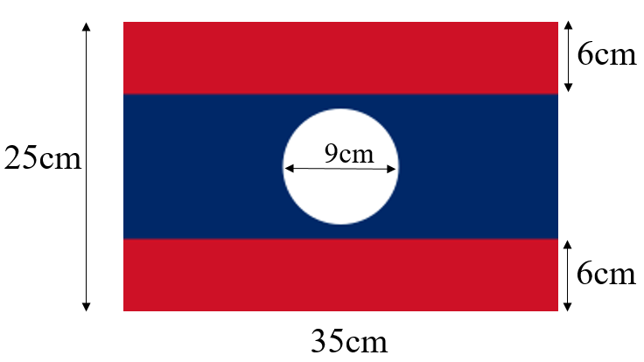
Flag of Laos. Find the areas
Flag of Greenland. Find the areas

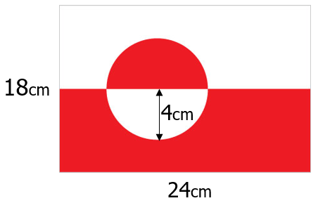

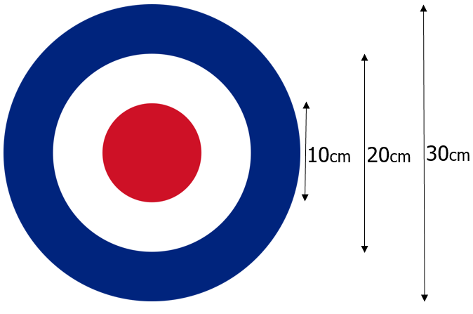

Extension
Flag of the RAF. Find the areas

